From https://www.wsj.com/articles/comedy-is-not-pretty-and-nowadays-it-isnt-even-funny-1517963485?mod=trending_now_1

Comedy Is Not Pretty, and Nowadays It Isn’t Even Funny

With sanctimony having replaced humor, the only thing left to laugh at is the farce of politics itself.
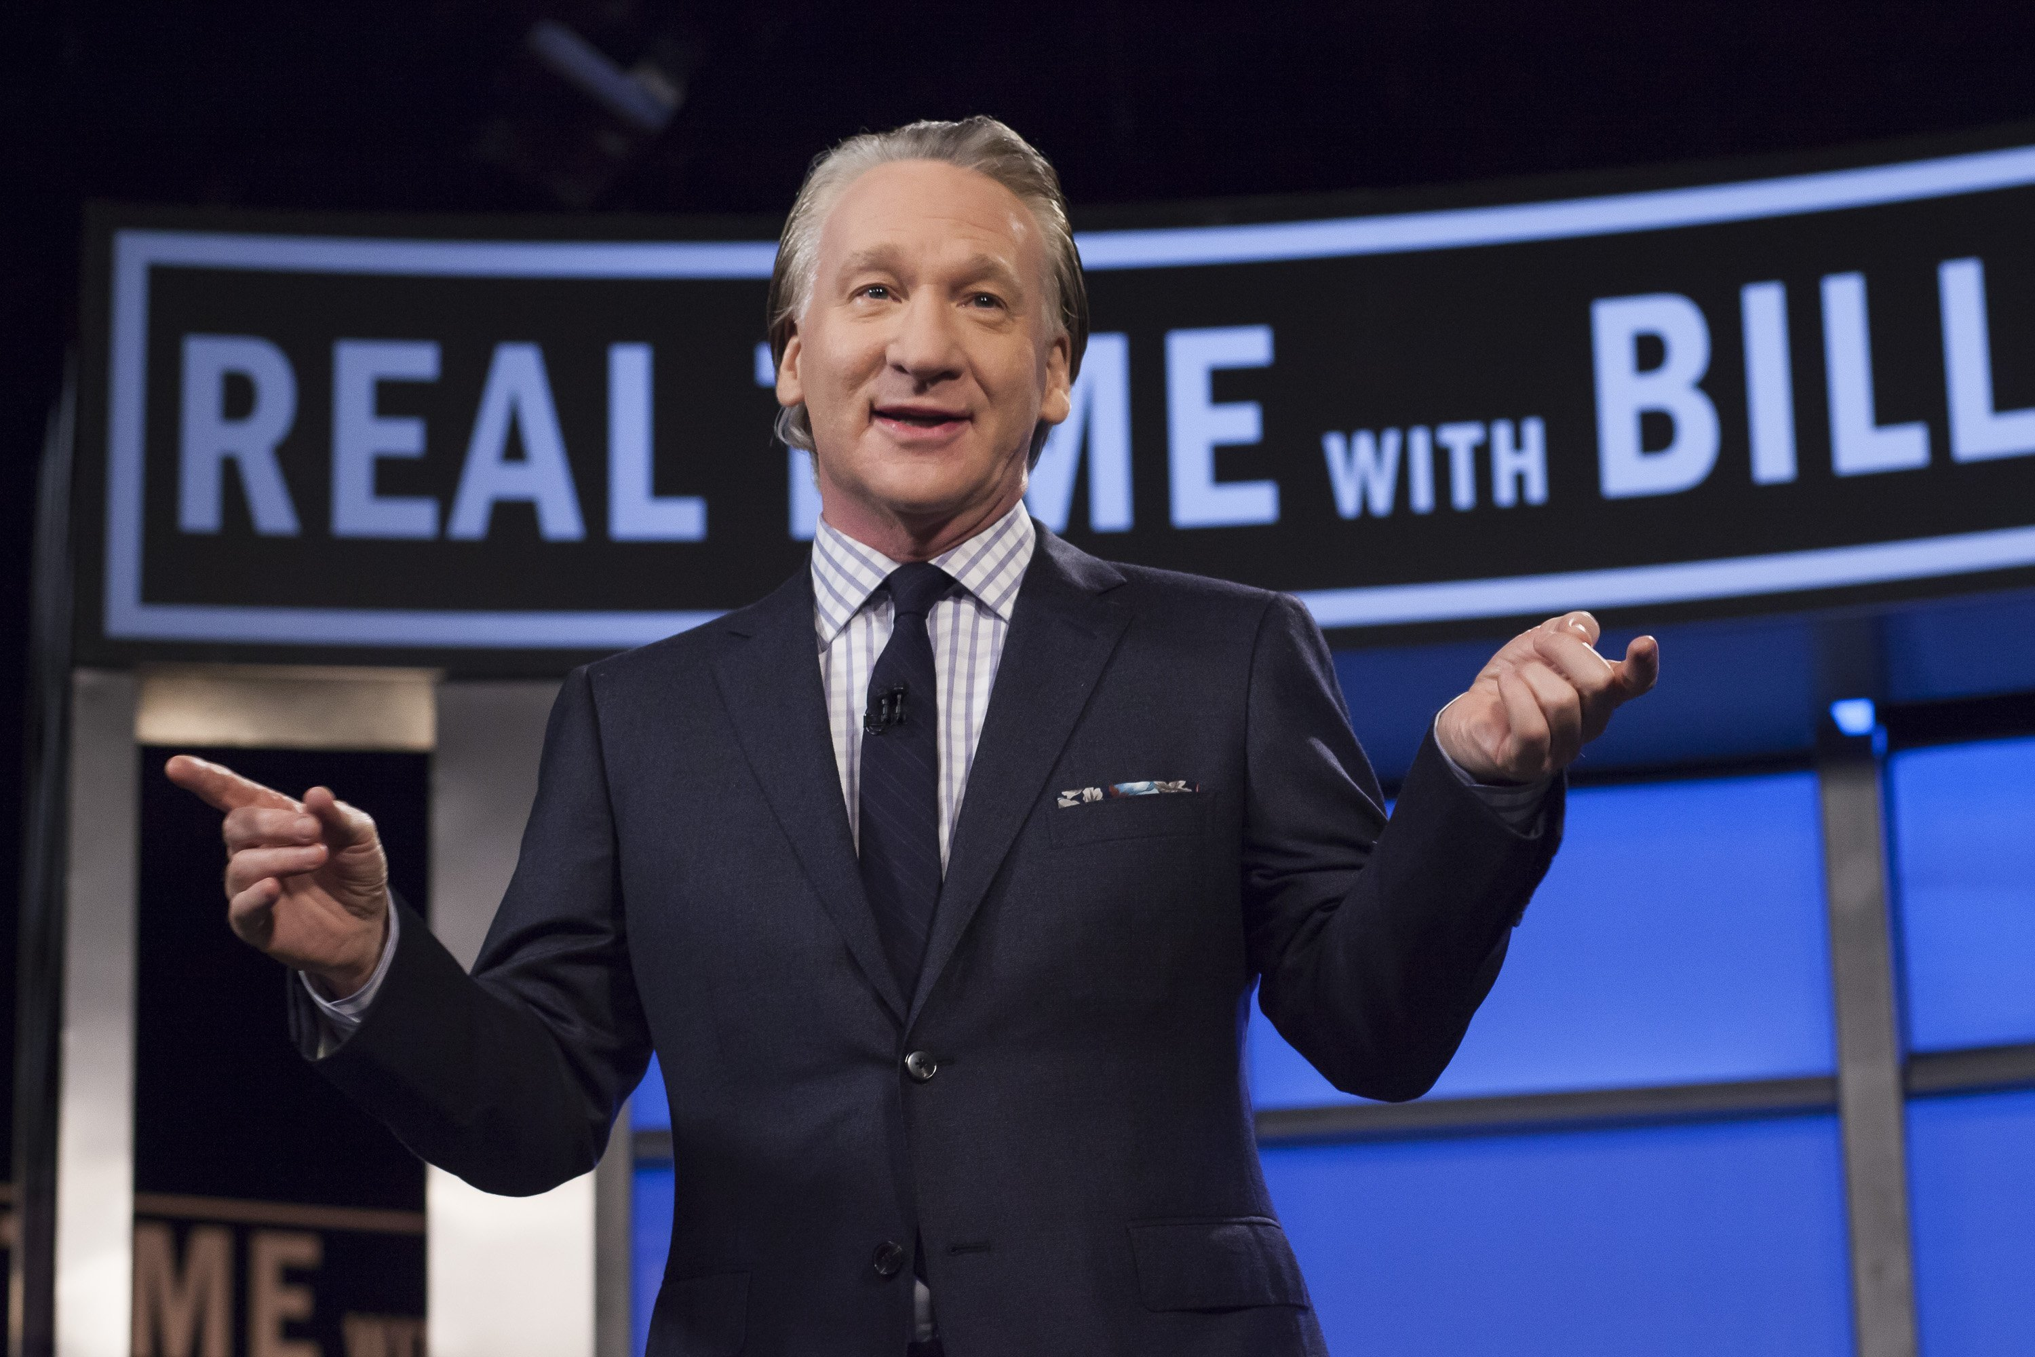
Comedian Bill Maher, host of HBO’s “Real Time with Bill Maher,” during a broadcast of the show in April 2016. PHOTO: JANET VAN HAM/HBO VIA ASSOCIATED PRESS
By
Joseph Epstein
Feb. 6, 2018 7:31 p.m. ET
675 COMMENTS
I found myself seated at my computer last month, watching on YouTube the comedian Bill Maher talk about Donald Trump’s marriage. If you don’t share Mr. Maher’s politics, you are likely to find him an odious, even loathsome character, for he doesn’t really exist outside politics. His standard tone is mockery, his modus operandi to lacerate his targets with obscenities, flash a nervous smile, and then bask in applause from his audience.
I was watching Mr. Maher on YouTube to see how far he would go on the subject of the Trump marriage. Would he attack the Trumps’ 11-year-old son, or perhaps attack the family for not having a dog? No surprise, he brought up the allegations of sexual harassment against Mr. Trump. Stormy Daniels was mentioned. His final punch line was that Melania Trump hadn’t accompanied her husband to Davos, Switzerland, because she had spent the day having to “lay a wreath on the tomb of the unknown trophy wife.”
Donald Trump has been a great boon to late-night talk-show hosts. His baroque hairdo, his hyperbole, his general extravagance, his unabashed egotism—all these things and more are in the wheelhouse of today’s liberal comedians. Without him, Bill Maher and Stephen Colbert, Jimmy Kimmel and Seth Meyers would be practically out of business. Jon Stewart must wake each morning filled with regret for his wretched timing at retiring just as Mr. Trump came into office.
Yet to have taken what I think of as the Trumpian option in their comedy has rendered these comedians charmless while strikingly limiting their audiences to those who share their politics. I recently wrote a book on the subject of charm, in preparation for which I asked a great many people to name five persons in public life they thought charming. No one could do it. In a political time as divisive as ours, a public figure loses roughly half his following—and hence his charm—just as soon as he announces his politics. For an entertainer to do so is perhaps even more hazardous.
That the late-night talk-show hosts are ready to give up a large share of the audience to indulge their politics is something new in American comedy. Whatever Jack Benny, the Marx Brothers, Milton Berle, Joan Rivers or Johnny Carson might have thought about what was happening in Washington, they wisely kept it to themselves. When Charlie Chaplin was revealed as a Communist fellow-traveler in the late 1930s it hurt his reputation, though he never allowed his politics directly to influence his art. On the other side, when Bob Hope found himself, because of his support for the Vietnam War, aligned with Richard Nixon, many of his most steadfast fans deserted him. The lesson, one should have thought, is that
comedy and politics don’t mix.
Unless, that is, the comedy is done with consummate subtlety. Mort Sahl, whom Steve Allen called “the only real political philosopher we have in modern comedy,” was one of the few with the talent to pull it off. I recall an instance when he appeared on the Johnny Carson show. Carson asked Mr. Sahl how he was. Not so good, the comedian answered. He had recently received a letter from the NAACP that admonished him, as a good liberal, for not having a black comedian in his act. Acknowledging his error, Mr. Sahl said he had hired a brilliant young black comic to work with him. Then he paused, looked down at his watch, and said, “He should have been here by now.” It took the audience fully 15 seconds to get the joke, when ripples, then roars of laughter followed.
Yet even Mr. Sahl lost ground when he became caught up, obsessed really, with conspiracy theories about the assassination of John F. Kennedy, and he spent years trying to regain, which he never quite did, his former cachet as the most brilliant of our comics. Clearly, Americans prefer that comedians keep their distance from political involvement.
Mr. Sahl, now in his 90s, still regularly appears before small audiences at a theater in California and occasionally sends out political tweets. Alas, none of this has the sharpness of Mort Sahl in his prime—but neither are his remarks about Donald Trump as coarse as the cheap-shot humor of our contemporary late-night hosts.
Enough people must share the views of these hosts to keep the careers of Maher, Colbert, Kimmel & Co. afloat, which is to say to keep their ratings high enough to be commercially viable. Yet these insufficiently funny comedians, with their crude political humor, do little more than add to the sad divisiveness that is rending the country. Something, surely, has been lost if one can no longer turn to comedy as a relief from the general woes of life and the greater farce that has for some years now been playing out in our everyday politics.
Mr. Epstein is author of the forthcoming “The Ideal of Culture and Other Essays” (Axios Press) and “Charm: The Elusive Enchantment” ( Taylor Trade), both to be published in 2018.
Appeared in the February 7, 2018, print edition.

